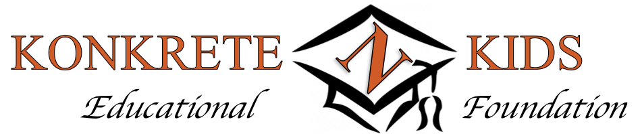

Tickets, Sponsorships, Contributions
2021 Distinguished Alumni Award Celebration
September 12, 2021

Please indicate your Ticket/Sponsorship choice by writing the number/placing an X on the line
preceding your selected “Sponsor” level.
Kindly provide the names of all attendees on reverse side of this form.

VIP Reception held at 4:30PM in Woodstone Lodge Lobby
Celebration Dinner, Recognition Program held at 6:00PM in Woodstone Grand Ballroom

_____ $75 – Individual Sponsor Includes one dinner, Distinguished Alumni Award Celebration *Please indicate on the line the number of Individual Sponsor tickets.

_____$125 – Benefactor Sponsor Includes one dinner, Distinguished Alumni Award Celebration Includes one entry to the VIP Reception
*Please indicate on the line the number of Benefactor Sponsor tickets.

_____$500 – K-Kids Sponsor Includes two dinners, Distinguished Alumni Award Celebration Includes two entries to the VIP Reception
Includes recognition of sponsorship in Celebration Program booklet

_____$1000 – Konkrete Sponsor Includes 2 dinners, Distinguished Alumni Award Celebration
Includes 2 entries to the VIP Reception
Includes Quarter-page recognition of sponsorship in Celebration Program booklet
Includes announced recognition during Celebration
Includes recognition on Foundation’s website for one year

_____$2500 – Black and Orange Includes 2 dinners, Distinguished Alumni Award Celebration
Sponsor Includes 2 entries to the VIP Reception
Includes Half-page recognition of sponsorship in Celebration Program
booklet
Includes announced recognition during Celebration and VIP Reception
Includes recognition on Foundation’s website for one year
Includes banner display at Celebration

Additional Sponsorship opportunities and Celebration Program ads available by contacting
the Distinguished Alumni Award committee at 610-767-7824.
The Northampton Area Konkrete Kids Educational Foundation is a 501(c)(3) nonprofit corporation.

CONTRIBUTIONS
Congratulatory Messages
Messages will be printed in the DAA CELEBRATION Program booklet that will be distributed at the event.
- Minimum of $100 contribution for printing of Message
(Please include Congratulatory Message payment with ticket/Sponsorship payment.)
- 150 characters or less in Message
Two options for Congratulatory Message (Please complete the following to have Message included in Program booklet.)
Option 1 Message) “Congratulations to All the Distinguished Alumni Award Honorees”
Message (optional)___________________________________________________________________________________
From: _________________________________________________________________________________________________

Option 2) “Congratulations to (Name of Specific Honoree) ____________________________________________________
Message (optional)__________________________________________________________________________________
From: ________________________________________________________________________________________________

Donations
_____I/We regretfully will not be able to attend, but would like to make a donation of $___________
All donations accepted. All donations of at least $100 will be listed in the Celebration Program booklet.
(Please send all monetary donations to DAA Committee at address listed below and include name and contact information.)

RAFFLE DONATIONS
As part of the Foundation’s fundraising efforts at the Celebration, a raffle will be held during
the after-dinner Recognition Program. Raffle donations, including specific items, services, products, gift
certificates, etc., are welcome, as well as cash donations that will be used to purchase items for the raffle. Recognition of all raffle donations will be included in the Celebration Program booklet.

________I/We would like to make an item/monetary donation to the Raffle.
**A member of the Distinguished Alumni Award committee will contact you for more specific information about your donation and to make arrangements to include your
donation in the Raffle. NAME________________________________________________
Phone________________________________________________

ATTENDEES
(Please complete the following for each Celebration attendee.)
Name (Please include Mr., Mrs., Ms) Address email (for updates on event)

____________________________________________________________________________________________________________________________________________________

____________________________________________________________________________________________________________________________________________________

____________________________________________________________________________________________________________________________________________________

____________________________________________________________________________________________________________________________________________________

____________________________________________________________________________________________________________________________________________________
***Please attach any additional attendee names and contact information.

Please make all checks payable to
Northampton Area Konkrete Kids Educational Foundation (NAKKEF)
and return this completed form to
Distinguished Alumni Award Committee, Box 816, Cherryville, PA 18035
as soon as possible, but no later than
Monday, August 9, 2021
For additional information, please contact 610-767-7824.

