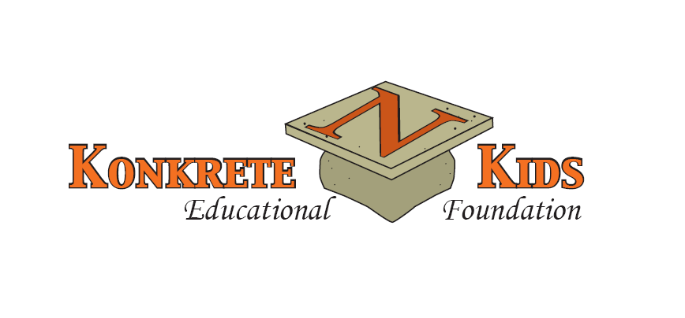

**DISTINGUISHED ALUMNI AWARD**

**Nomination Information**

**PURPOSE STATEMENT**

The **Distinguished Alumni Award,** sponsored by the Northampton Area Konkrete Kids Educational

Foundation, will make current Northampton Area School District students, graduates, and the community

aware that our school district produces outstanding graduates and role models who have demonstrated

leadership and excellence in their professional and personal lives.

**NOMINATION CRITERIA**

A candidate for the **Distinguished Alumni Award** must have graduated from Northampton Area

High School **at least 15 years prior** to his/her nomination for the Award. A nominee does not need to be

a current resident of the Northampton Area School District, but the nominee should reflect some of the

following criteria:

- a person who has achieved outstanding success in his/her chosen field or profession

- a person who has performed substantial community service or volunteer work

- a person who has made a positive impact on others

- a person who has received special recognition or awards

*****Posthumous nominations will be accepted.

**SELECTION**

All nominations submitted by the Monday, March 20, 2023, deadline will be carefully reviewed by the

Distinguished Alumni Award Committee, and the selected DAA honoree(s) will be notified in April 2023.

**AWARDS PROGRAM**

The selected honoree(s) for the **Distinguished Alumni Award** will have a permanent plaque placed on

the **Distinguished Alumni Wall of Honor** located in the main lobby ofNorthampton Area High School,

and the Award recipient(s) will be publicly honored at the **Distinguished Alumni Award CELEBRATION** on

September 17, 2023, at Woodstone Country Club and Lodge, Danielsville, PA.

**Nomination Forms may be submitted as soon as possible, but no later than the**

**Monday, March 20, 2023, deadline.**

**____________________________________________________________________________________________________________________________**

Mail or Email **DISTINGUISHED ALUMNI AWARD Nomination Form(s)** by **March 20, 2023** to:

Northampton Area Konkrete Kids Educational Foundation

Attn. Distinguished Alumni Award Committee

PO Box 816, Cherryville, PA 18035

Visit the Northampton Area Konkrete Kids Educational Foundation (www.konkretefoundation.org) for additional information

or call 610-767-7824.